**Nana Upstairs and Nana Downstairs (Response, Level F1)**

The teacher asked the students to choose a passage from the text that was important to them or had special meaning to the writer. This child chose a double-entry log to respond to Tomie de Paola’s Nana Upstairs and Nana Downstairs. The book’s selected passage is on the left.

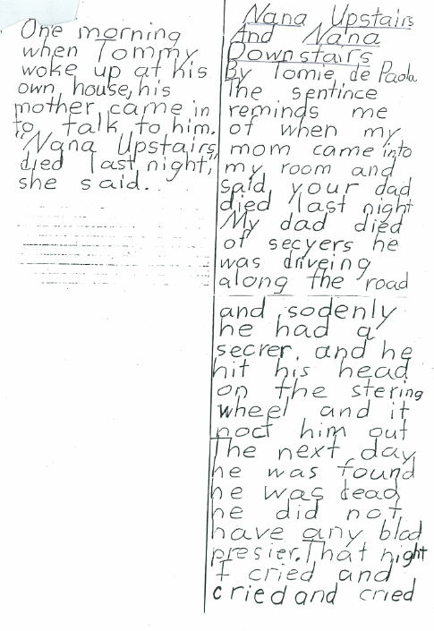

|  |  |
| --- | --- |
| One morning when Tommy woke up at his own house, his mother came in to talk to him. “Nana Upstairs died last night,” she said. | Nana Upstairs and Nana Downstairs by Tomie de Paola  The sentence reminds me of when my mom came into my room and said, “Your dad died last night.”  My dad died of seizures. He was driving along the road, and suddenly he had a seizure. And he hit his head on the steering wheel, and it knocked him out. The next day he was found. He was dead. He didn’t have any blood pressure.  That night, I cried and cried and cried. |

Ideas/Content:

1. Response makes direct connections to the text and writer’s personal tragic experience.
2. Events are developed with enough detail to elicit reader’s emotional response.

Structure/Organization:

1. Includes an introductory sentence that parallels the book.
2. Includes several events in order.
3. Includes an ending.

Voice/Point of View:

1. Shows emotion
2. 1st person with some narration

Word Choice/Description:

1. Tells story like author is talking, but has not developed the ability to expand sentences with more description.
2. Uses specific nouns such a *blood pressure* and *seizures*.

Sentence Fluency/Structure:

1. Does not use punctuation to separate sentences over uses conjunctions creating run-on sentences.
2. Includes one complex sentence.
3. Attempts to use dialogue but doesn’t know how to punctuate.
4. Includes several compound sentences.
5. Has several sentences with an introductory word (adverb: *suddenly*) or transitional words (*The next day; That night).*